Ethernet Cabling and Connectors

5.1 Twisted Pair Cabling
Twisted pair cables are so named because pairs of wires are twisted around one another. Each pair consists of two insulated copper wires twisted together. The wire pairs are twisted because it helps reduce crosstalk and noise susceptibility. High quality twisted pair cables have about 1 to 3 twists per inch. For best results, the twist rate should vary significantly between pairs in a cable.
Twisted pair cables are used with the following Ethernet physical layers: 10Base-T, 100Base-TX, 100Base-T2, 100Base-T4, and 1000Base-T. The following sections describe the various types of twisted pair cabling.

5.1.1 Unshielded Twisted Pair Cabling (UTP)
As the name implies, "unshielded twisted pair" (UTP) cabling is twisted pair cabling that contains no shielding. For networking applications, the term UTP generally refers to the 100 ohm, Category 3, 4, & 5 cables specified in the TIA/EIA 568-A standard. Category 5e, 6, & 7 standards have also been proposed to support higher speed transmission. UTP cabling most commonly includes 4 pairs of wires enclosed in a common sheath. 10Base-T, 100Base-TX, and 100Base-T2 use only 2 of the twisted pairs, while 100Base-T4 and 1000Base-T require all 4 twisted pairs.
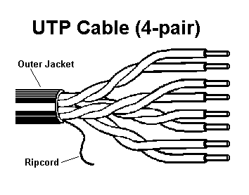
The following is a summary of the UTP cable Categories:
- Category 1 & Category 2 - Not suitable for use with Ethernet.
- Category 3 - Unshielded twisted pair with 100 ohm impedance and electrical characteristics supporting transmission at frequencies up to 16 MHz. Defined by the TIA/EIA 568-A specification. May be used with 10Base-T, 100Base-T4, and 100Base-T2.
- Category 4 - Unshielded twisted pair with 100 ohm impedance and electrical characteristics supporting transmission at frequencies up to 20 MHz. Defined by the TIA/EIA 568-A specification. May be used with 10Base-T, 100Base-T4, and 100Base-T2.
- Category 5 - Unshielded twisted pair with 100 ohm impedance and electrical characteristics supporting transmission at frequencies up to 100 MHz. Defined by the TIA/EIA 568-A specification. May be used with 10Base-T, 100Base-T4, 100Base-T2, and 100Base-TX. May support 1000Base-T, but cable should be tested to make sure it meets 100Base-T specifications.
- Category 5e - Category 5e (or "Enhanced Cat 5") is a new standard that will specify transmission performance that exceeds Cat 5. Like Cat 5, it consists of unshielded twisted pair with 100 ohm impedance and electrical characteristics supporting transmission at frequencies up to 100 MHz. However, it has improved specifications for NEXT (Near End Cross Talk), PSELFEXT (Power Sum Equal Level Far End Cross Talk), and Attenuation. To be defined in an update to the TIA/EIA 568-A standard. Targetted for 1000Base-T, but also supports 10Base-T, 100Base-T4, 100Base-T2, and 100BaseTX.
- Category 6 - Category 6 is a proposed standard that aims to support transmission at frequencies up to 250 MHz over 100 ohm twisted pair.
- Category 7 - Category 7 is a proposed standard that aims to support transmission at frequencies up to 600 MHz over 100 ohm twisted pair.

5.1.2 Screened Twisted Pair (ScTP)
Screened Twisted Pair (ScTP) is 4-pair 100 ohm UTP, with a single foil or braided screen surrounding all four pairs in order to minimize EMI radiation and susceptibility to outside noise. Screened twisted pair is also called Foil Twisted Pair (FTP), or Screened UTP (sUTP). ScTP can be thought of as a shielded version of the Category 3, 4, & 5 UTP cables. It may be used in Ethernet applications in the same manner as the equivalent Category of UTP cabling.

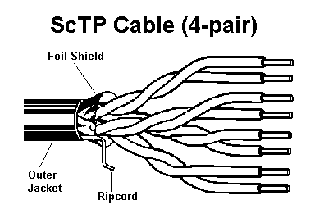

5.1.3 Shielded Twisted Pair Cabling (STP)
Although screened twisted pair (ScTP) is technically a form of shielded twisted pair, the term "shielded twisted pair" (STP) most often refers to the 150 ohm twisted pair cabling defined by the IBM Cabling System specifications for use with Token-Ring networks. The twisted pairs in 150 ohm STP are individually wrapped in a foil shield and enclosed in an overall outer braided wire shield. The shielding is designed to minimize EMI radiation and susceptibility to crosstalk. 150 ohm STP is not generally intended for use with Ethernet. However, the Ethernet standard does describe how it can be adapted for use with 10Base-T, 100Base-TX, and 100Base-T2 Ethernet by installing special impedance matching transformers, or "baluns", that convert the 100 ohm impedance of the Ethernet transceivers to the 150 ohm impedance of the STP cable. These baluns are available from companies such as AMP, IBM, and Cambridge Connectors.
The various versions of 150 ohm STP cable are identified by a "Type" number. The original IBM Cabling System specifications defined STP cable Types 1, 2, 6, 8, & 9 for support of Token-Ring frequencies up to 16 MHz. Later, an enhanced IBM Cabling System defined STP-A cable Types 1A, 2A, 6A, & 9A for support of FDDI frequencies up to 100 MHz. The "A" suffix denotes the enhanced IBM Cabling System. Type 1 is the heavy black cable that is most commonly associated with the IBM Cabling System. It contains only 2 twisted pairs as compared to UTP and ScTP which typically contain 4 twisted pairs. Note that 100Base-T4 and 1000Base-T cannot be adapted to use STP because they require a cable with 4 twisted pairs.

5.2 Coaxial Cabling
Coaxial cable is a type of communication transmission cable in which a solid center conductor is surrounded by an insulating spacer which in turn is surrounded by a tubular outer conductor (usually a braid, foil or both). The entire assembly is then covered with an insulating and protective outer layer. Coaxial cables have a wide bandwidth and are capable of carrying many data, voice, and video conversations simultaneously.
The following sections describe the various types of coaxial cabling used with Ethernet.

5.2.1 Thicknet
Thicknet is the 50-ohm "thick" (10mm) coaxial cable used with Ethernet 10Base5 networks. 10Base5 is the original Ethernet system that supports a 10 Mb/s transmission rate over a 500 meter maximum supported segment length.
Thick Ethernet coaxial cabling includes a "mark" every 2.5 meters to indicate proper placement of the 10Base5 transceivers (or MAUs) used to connect stations to the network. Transceivers may be placed at any multiple of 2.5 meter intervals. This minimizes signal reflections that may degrade the transmission quality of the cable segment. The outer jacket of Thick Ethernet cables is typically a bright color (often yellow) with black bands at 2.5 meter intervals to mark valid transceiver placement points.
10Base5 transceivers are attached through a clamp that makes physical and electrical contact with the cable. They are also called "transceiver taps" because they are connected through a process known as "tapping" that drills a hole in the cable to allow electrical contact to be made. The transceivers are called "non-intrusive" taps because the connection can be made on an active network without disrupting traffic flow.
The standard allows a 10Base5 coaxial cable segment to be up to 500 meters in length. Up to 100 transceivers may be connected to a single segment at any multiple of 2.5 meters apart. A 10Base5 segment may consist of a single continuous section of cable, or be assembled from multiple cable sections that are attached end to end. If multiple cable sections are used, it can result in "impedance mismatches" that are caused by slight differences in the impedance of each cable section. When excessive, these mismatches can cause signal reflections that result in bit errors and discarded frames. Segments with multiple sections are often built with cable that comes from a single spool. This ensures each section of the cable segment will have consistent impedance since it was built by one manufacturer, at one time, using the same equipment. Cable segments can be joined at any point along their length and are not restricted to 2.5 meter intervals like transceivers.
10Base5 coaxial cable segments are built using "N-type" connectors. Each end of a segment must have a N-type coaxial connector with N-type 50-ohm terminators installed. Two sections of a segment are interconnected using two N-type coaxial connectors that are mated together through a N-type barrel connector. Long 10Base5 segments typically have one or more barrel connectors to allow the segment to be split for purposes of problem isolation. For safety reasons, the standard specifies that a cable segment should be connected to earth ground at one and only one point. This may be done at the terminator at the end of the cable, or at a barrel connector where two segments are joined.

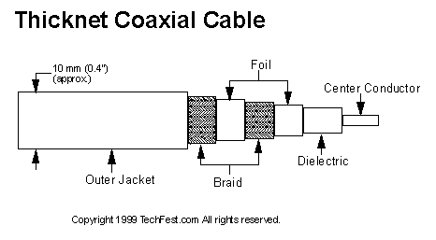

5.2.2 Thinnet
Thinnet is the 50-ohm "thin" (5mm) coaxial cable used with Ethernet 10Base2 networks. 10Base2, also known as "Thin Ethernet", or "cheapernet", supports a 10 Mb/s transmission rate over a 185 meter maximum supported segment length.
The Thinnet cable used by 10Base2 has the advantages of being cheaper, lighter, more flexible, and easier to install than the Thicknet cable used by 10Base5. However the thin cable has the disadvantage that its transmission characteristics are not as good. It supports only a 185 meter maximum segment length (vs. 500 meters for 10Base5) and a maximum of 30 stations per cable segment (vs. 100 for 10Base5).
10Base2 transceivers (MAUs) are connected to the Thinnet cable segment through a "BNC Tee" connector, and not through "tapping" as with 10Base5. As the name implies, the BNC Tee connector is shaped like the letter "T". The horizontal part of the "T" includes female connectors that mate with the male BNC coaxial connectors on each end of the attaching cable sections. The vertical part of the "T" includes a male BNC connector that either plugs directly into the Ethernet network interface card (NIC) in the computer station, or to an external thin Ethernet transceiver that is then attached to the NIC through a standard AUI cable. If stations are removed from the network, the "T" connector is removed and replaced with a "BNC Barrel" connector that provides a straight through connection.
Each end of a 10Base2 coaxial segment must be terminated with a BNC 50-ohm terminator. For safety reasons, a ground wire should connect the segment to earth ground at one point, typically at the terminator on the end of the segment.
The 10Base2 standard states that the coaxial cable types known as RG58A/U and RG58C/U can meet the cable specifications in the standard. However the specifications for these cable designations are not precise, and the construction of RG58A/U and RG58C/U cables may vary from one manufacturer to another. To make sure you are getting the right cable, you should specifically request cable that is guaranteed to meet the IEEE 10Base2 thin Ethernet specifications.

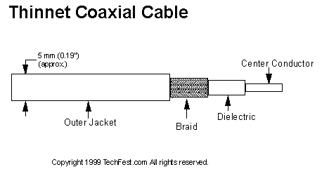

5.2.3 CATV
CATV cabling is the 75 ohm coaxial cabling commonly known for its use in transmission of Cable TV signals, but is also used with Ethernet 10Broad36 networks. CATV stands for "community antenna television".
CATV cabling is used for "broadband" transmission as opposed to the "baseband" transmission used by all other Ethernet physical layers. A broadband cabling system supports transmission of multiple services over a single cable by dividing the bandwidth into separate frequencies, with each frequency assigned to a different service. This technique is used in cable TV transmission systems to transmit multiple channels over a single cable. Each channel uses a different frequency range. This capability can allow 10Broad36 share a single cable with other services such as video.

5.2.4 Twinax
Twinax, or twinaxial, is a type of communication transmission cable consisting of two center conductors surrounded by an insulating spacer which in turn is surrounded by a tubular outer conductor (usually a braid, foil or both). The entire assembly is then covered with an insulating and protective outer layer. Twinax is constructed much like coaxial cable, execpt it has two center conductors instead of one. However, it is similar to twisted pair cabling in that it uses differential, or "balanced", transmission. 150-ohm twinax is specified as a "short haul" cable that can be used with the 1000Base-CX media system. Although twinax has better transmission characteristics than twisted pair media, it supports segment lengths of only 25 meters for 1000Base-CX due to the very high 1.25 Gbaud signal transmission rate.

5.3 Fiber Optic Cabling
Fiber optic cabling is a technology where electrical signals are converted into optical signals, transmitted through a thin glass fiber, and re-converted into electrical signals. It is used as transmission medium for the following Ethernet media systems: FOIRL, 10Base-FL, 10Base-FB, 10Base-FP, 100Base-FX, 1000Base-LX, and 1000Base-SX.
Fiber optic cabling is constructed of three concentric layers: The "core" is the central region of an optical fiber through which light is transmitted. The "cladding" is the material in the middle layer. It has a lower index of refraction than the core which serves to confine the light to the core. An outer "protective layer", or "buffer", serves to protect the core and cladding from damage.
The following sections describe the two primary types of fiber optic cabling: "multi-mode fiber" and "single-mode fiber".

5.3.1 Multi-Mode Fiber (MMF)
Multi-mode fiber allows many "modes", or paths, of light to propagate down the fiber optic path. The relatively large core of a multi-mode fiber allows good coupling from inexpensive LEDs light sources, and the use of inexpensive couplers and connectors. Multi-mode fiber typically has a core diameter of 50 to 100 microns.
Two types of multi-mode fiber exist with a refractive index that may be "graded" or "stepped". With graded index fiber the index of refraction of the core is lower toward the outside of the core and progressively increases toward the center of the core, thereby reducing modal dispersion of the signal. With stepped index fiber the core is of uniform refractive index with a sharp decrease in the index of refraction at the core-cladding interface. Stepped index multi-mode fibers generally have lower bandwidths than graded index multi-mode fibers.
The most popular fiber for networking is the 62.5/125 micron multi-mode fiber. These numbers mean that the core diameter is 62.5 microns and the cladding is 125 microns. Other common sizes are 50/125 and 100/140.
The primary advantage of multi-mode fiber over twisted pair cabling is that it supports longer segment lengths. Multi-mode fiber can support segment lengths as long as 2000 meters for 10 and 100 Mbps Ethernet, and 550 meters for 1 Gbps Ethernet.

5.3.2 Single-Mode Fiber (SMF)
Single-mode fiber has a core diameter that is so small (on the order of 10 microns) that only a single mode of light is propagated. This eliminates the main limitation to bandwidth, modal dispersion. However, the small core of a single-mode fiber makes coupling light into the fiber more difficult, and thus expensive lasers must be used as light sources. The main limitation to the bandwidth of a single-mode fiber is material (chromatic) dispersion. Laser sources must also be used to attain high bandwidth, because LEDs emit a large range of frequencies, and thus material dispersion becomes significant.
Single-mode fiber is capable of supporting much longer segment lengths than multi-mode fiber. Segment lengths of 5000 meters and beyond are supported at all Ethernet data rates through 1 Gbps. However, single-mode fiber has the disadvantage of being significantly more expensive to deploy than multi-mode fiber.

5.4 Ethernet Connectors

5.4.1 RJ-45
An "RJ-45" connector is used on Ethernet twisted pair links. This includes the 10Base-T, 100Base-TX, 100Base-T4, 100Base-T2, and 1000Base-T physical layer types. An RJ-45 connector has 8-pins, and may also be referred to as an "8-pin Modular Connector". A male RJ-45 "plug" is mounted on each end of the twisted pair cable. A female RJ-45 "jack" or "receptacle" is integrated into the Ethernet hub or NIC.

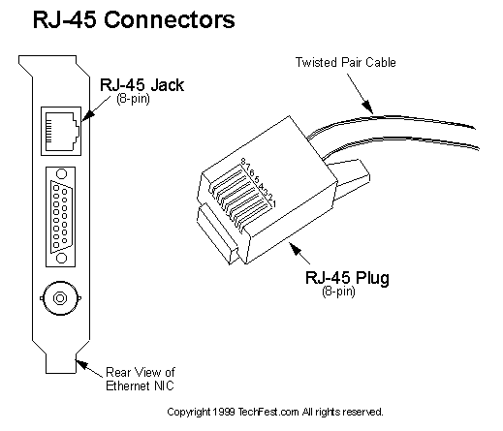
The following table shows the RJ-45 connector pin assignments for each of the Ethernet twisted pair physical layer types.

Contact | 10Base-T Signal | 100Base-TX Signal | 100Base-T4 Signal | 100Base-T2 Signal | 1000Base-T Signal
1 | TD+ (Transmit Data) | TD+ (Transmit Data) | TX_D1+ (Transmit Data) | BI_DA+ (Bidi Data) | BI_DA+ (Bidi Data)
2 | TD- (Transmit Data) | TD- (Transmit Data) | TX_D1- (Transmit Data) | BI_DA- (Bidi Data) | BI_DA- (Bidi Data)
3 | RD+ (Receive Data) | RD+ (Receive Data) | RX_D2+ (Receive Data) | BI_DB+ (Bidi Data) | BI_DB+ (Bidi Data)
4 | Not used | Not used | BI_D3+ (Bidi Data) | Not used | BI_DC+ (Bidi Data)
5 | Not used | Not used | BI_D3- (Bidi Data) | Not used | BI_DC- (Bidi Data)
6 | RD- (Receive Data) | RD- (Receive Data) | RX_D2- (Receive Data) | BI_DB- (Bidi Data) | BI_DB- (Bidi Data)
7 | Not Used | Not Used | BI_D4+ (Bidi Data) | Not used | BI_DD+ (Bidi Data)
8 | Not Used | Not Used | BI_D4- (Bidi Data) | Not used | BI_DD- (Bidi Data)

5.4.2 AUI
The following table shows the assignment of the 15-pin AUI, or "attachment unit interface", connector:
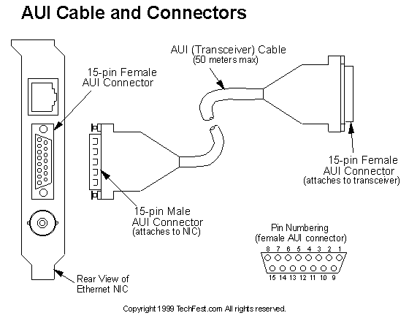

Pin | IEEE 802.3 Signal Name | DIX Signal Name
1 | Control In circuit shield | Shield
2 | Control In circuit A | Collision Presence +
3 | Data Out circuit A | Transmit +
4 | Data In circuit shield | -
5 | Data In circuit A | Receive +
6 | Voltage Common | Power Return
7 | Control Out Circuit A | -
8 | Control Out Circuit shield | -
9 | Control In Circuit B | Collision Presence -
10 | Data Out circuit B | Transmit -
11 | Data Out circuit shield | -
12 | Data In circuit B | Receive -
13 | Voltage Plus | Power
14 | Voltage Shield | -
15 | Control Out circuit B | -
Shell | Protective Ground (conductive shell) | -

5.4.3 MII
The following table shows the assignment of the 40-pin MII, or "media independent interface", connector:
Pin | Signal Name | Pin | Signal Name | Pin | Signal Name | Pin | Signal Name
1 | +5V | 11 | TX_ER | 21 | +5V | 31 | COMMON
2 | MDIO | 12 | TX_CLK | 22 | COMMON | 32 | COMMON
3 | MDC | 13 | TX_EN | 23 | COMMON | 33 | COMMON
4 | RXD<3> | 14 | TXD<0> | 24 | COMMON | 34 | COMMON
5 | RXD<2> | 15 | TXD<1> | 25 | COMMON | 35 | COMMON
6 | RXD<1> | 16 | TXD<2> | 26 | COMMON | 36 | COMMON
7 | RXD<0> | 17 | TXD<3> | 27 | COMMON | 37 | COMMON
8 | RX_DV | 18 | COL | 28 | COMMON | 38 | COMMON
9 | RX_CLK | 19 | CRS | 29 | COMMON | 39 | COMMON
10 | RX_ER | 20 | +5V | 30 | COMMON | 40 | +5V

